**TITAN of the industry and icon of modern India**

[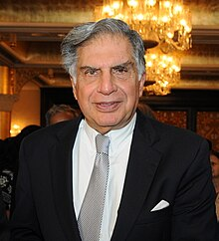](https://en.wikipedia.org/wiki/File:Ratan_Tata_2011_(The_TCS_Story_Launch_-_CII)_(cropped).jpg)

**Ratan naval Tata**

**Ratan Naval Tata** (28 December 1937 – 9 October 2024) was an Indian industrialist and philanthropist. He served as the chairman of Tata Group and Tata Sons from 1991 to 2012 and he held the position of interim chairman from October 2016 to February 2017. Tata was regarded as a visionary leader, and his legacy is one of compassion and innovation that tracends the confines of the corporate realm to impact millions of ordinary lives.

EARLY LIFE

Tata studied at the Campion School, Mumbai until 8th grade. He then continued his studies at the Cathedral and John Connon School in Mumbai, the Bishop Cotton School in Shimla, and the Riverdale Country School in New York City, from which he graduated in 1955. After high school, Tata enrolled in Cornell University, from which he graduated with a bachelor's degree in architecture in 1962.  In 1975, Tata enrolled in the Advanced Management Program at Harvard Business School. He acquired his business training on the job, gaining experience in a number of Tata Group businesses, and was named director in charge (1971) of one of them, the National Radio and Electronics Co. He became chairman of Tata Industries a decade later, and in 1991 he succeeded his uncle, J.R.D. Tata, as chairman of Tata Sons, the parent company of the Tata Groups.

**CAREE**R

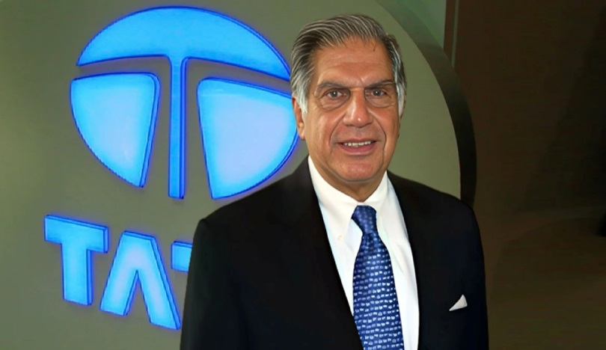

Ratan Tata became chairman of Tata Sons at a crucial period of India’s growth story: the liberalization of its economy. . Tata aggressively sought to expand the conglomerate, and increasingly he focused on globalizing its business. Tata guided the group through periods of economic reform and globalization, helping shape the Indian business landscape for over two decades. Beyond his business acumen, Tata was recognized for his integrity, ethical leadership, and commitment to philanthropy, making him an iconic figure both in India and internationally. Under his leadership, Tata Group expanded globally, acquiring companies like Tetley, Jaguar Land Rover, and Corus, and launching innovative products like the Tata Nano. Yet, Ratan Tata’s vision was always aligned with social well-being, as demonstrated through his commitment to charitable.

## THE LEGACY OF PHILANTHROPY

He was greatly admired for his philanthropic interests, which included supporting research and improvements in medicine, and rural development.  
As chairman of the Tata Trusts—one of India’s oldest and most significant charitable organisation. His personal dedication causes beyond mere financial contribution. Tata was instrumental in establishment of numerous educational institutions and so many other social welfare, helping countless individual across the country. Tata was advocate for using wealth as societal welfare. His legacy in this regard is profound—ensuring that the fruits of his success

National awards such as the Padma Bhushan and the Padma Vibhushan, countless honorary degrees from educational institutes the world over, and several awards from Indian Government ,Tata have also received the following global recognitions from other countries, chiefly for helping strengthen economic ties between India and these countries:

* + Medal of the Eastern [now Oriental] Republic of Uruguay (2004), from the Government of Uruguay
  + Grand Cordon of the Order of rising sun (2012), from the Government of Japan
  + Honorary Knight Grand Cross of the Order of the British Empire (GBE; 2014), conferred by Queen Elizabeth II
  + Commander of the Legion of Honour (2016), awarded by the Government of France
  + Honorary Officer of the Order of Australia (2023), award by king Charles III

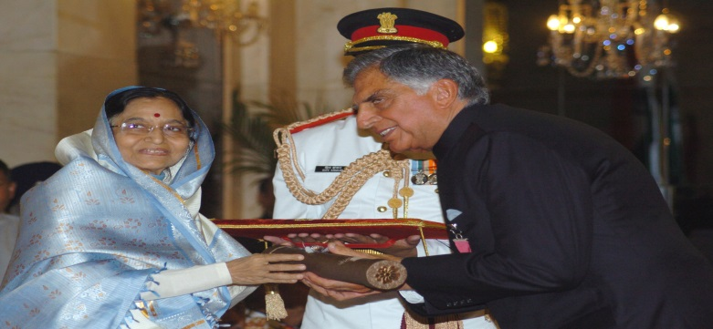

Perhaps the most defining trait of Ratan Tata’s leadership was his unwavering adherence to ethical principles. In era marked by cooperated greed’s and misconduct. Tata was beacon of integrity. Tata’s retirement in 2012 marked the end of an era for the conglomerate, but his Tata’s retirement in 2012 marked the end of an era for the conglomerate, but his influence remained palpable. He continued encouraging young mentor and entrepreneurs towards India’s burgeoning start-ups.

Tata leaves a legacy that transcends from corporate world . His vision, restless pursuit and companion of excellence have a left an indelible mark on India and world

Tata life is testament to belief that business when conduct with integrity, can be for good.